Types of IPv4 Addresses

Public and Private IPv4 Addresses

Just as there are different ways to transmit, there are also different typesof IPv4

Public IPv4 addresses

**Addresses which are globally routed between internet service provider (ISP) routers**

However, not all available IPv4 addresses can be used on the internet

There are blocks of addresses called private addresses that are **used by most organizations to assign IPv4 addresses to internal host**s

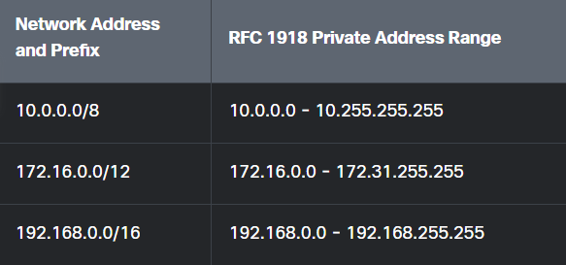

Note: Private addresses are defined in RFC 1918 and sometimes

referred to as RFC 1918 address space.

Routing to the internet

**Most internal networks, from large enterprises to home networks, use private IPv4 addresses for addressing all internal devices including hosts and routers**

BUT private addresses are not globally routable

In the figure, customer networks 1,2,3

are sending packets outside their internal networks

These packets have a source IPv4 address that is a private address and a destination IPv4 address that is public.

Packets with a private address must be filtered (discarded) or translated to a public address before forwarding the packet to an ISP

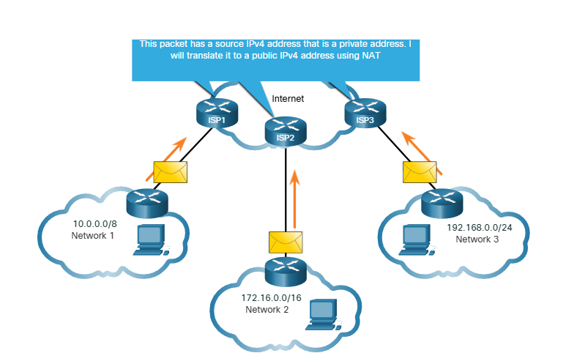

**Before the ISP can forward this packet, it must translate the source IPv4 address to a public one using network address translation (NAT)**

**NAT is used to translate between private and public IPv4 addresses and is usually done on the router that connects the internal network to the ISP network**

Special use IPv4 addresses

There are special addresses, such as the network address and broadcast address, that cannot be assignet to hosts.

There are also special addresses that can be assigned to hosts, but with restrictions on how those hosts can interact within the network

Loopback addresses

**(127.0.0.0 /8 or 127.0.0.1 to 127.255.255.254)**

Are more **commonly identified as only 127.0.0.1**

**They are used by a host to direct traffic to itself**

Link-local addresses

**(169.254.0.0 /16 or 169.254.0.1 to 169.254.255.254)**

**Commonly known as Automatic Private IP addressing (APIPA) addresses**

or self-assigned addresses

**They are used by a windows client to self-configure in the event that the client cannot obtain an IP addressing through other methods**

Legacy classful addressing

1981 RFC 790 -- three classes A,B,C ant the classes were:  
 Class A (0.0.0.0/8 to 127.0.0.0/8)

Designed to support extremely large networks with more than 16Mil host addresses

Class B (128.0.0.0/16 to 191.255.0.0/16)

Designed to support the needs of moderate to large size networks  
 about 65000 host addresses

Class C (192.0.0.0/24 to 223.255.255.0/24)

Designed to support small networks with a maximum of 254 hosts

There is also a Class D multicast block consisting of 224.0.0.0 to 239.0.0.0 and a Class E experimental address block consisting of 240.0.0.0 - 255.0.0.0.

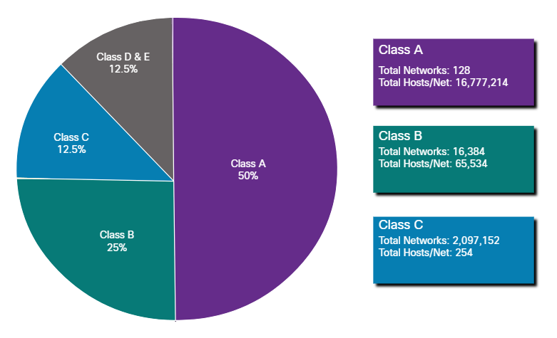

Assignment of IP addresses

Public IPv4 addresses are addresses which are globally routed over the internet  
 and must be unique

Both IPv4 and IPv6 addresses are managed by the internet assigned numbers authority (IANA)

They allocate blocks of IP addresses to the regional internet registry (RIRs)

RIRs are responsible for allocating IP addresses to ISPs who provide IPv4 address blocks to organizations and smaller ISPs

